**Vendor Application**

*St. Andrew’s United Church  
Christmas Craft Sale & Silent Auction*

*November 08, 2025 9am to 2pm*

[www.standrewsuc.ca](http://www.standrewsuc.ca)

***Please read the following carefully.***

Submitting this application signifies your agreement to the following terms:

1. ***NOTE***: Submission of this application does not guarantee a space at the Craft Show. The Vendor Co-ordinator will contact you if there are any issues/questions about your application.
2. You agree to include the full amount for your table rental with the application (**cash, cheque**  (payable to **St. Andrew’s United Church) or EFT standrewsgeorgetown89@gmail.com**). In the unlikely circumstances that the event is postponed or cancelled, or if your application is turned down, St. Andrew’s United Church will refund this payment. A receipt for the registration fee will be available upon request.
3. You agree to sell only the types of items you have listed, and for which photos have been submitted, and that you will not sell items that are not visually appropriate for all ages. Larger items must either fit under the table or go behind the table. Due to our limited space, nothing is to block the aisles or block other vendors’ displays.
4. You commit to being fully set up by 8:45 am on the day of the sale and will not start packing up until 2:00pm. (The doors will open at 7:30 am on Saturday for vendors with set up Friday night available by prior arrangement). *Please note:* while the church is fully accessible, there will be no trolleys or carts provided for vendor use. There is an elevator should your table assignment be on the lower level and we will have helpers available.
5. You agree that St. Andrew’s United Church is not responsible for the loss, breakage or theft of any of your wares or personal belongings.
6. You take full legal responsibility for your wares (this is mainly pertinent to consumables.) *Please note*: that we try to keep our facility scent free. Please clearly label any/all food items for sale.
7. 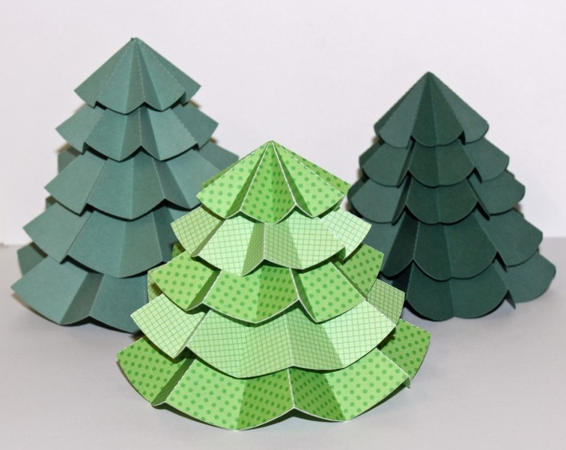 You consent to having your photograph, and those of anyone with you, taken and published on the St. Andrew’s United Church website (No identifying information will be added to photos.)

**Vendor Application**

*St. Andrew’s United Church  
Christmas Craft Sale & Silent Auction*

*November 08, 2025 - 9am to 2pm*

[www.standrewsuc.ca](http://www.standrewsuc.ca)

|  |  |  |  |  |  |  |
| --- | --- | --- | --- | --- | --- | --- |
| Name: |  | | | | | |
| Business Name: |  | | | | | |
| Street Address: |  | | | | | |
| Town: |  | | Postal Code: |  | | |
| Phone: |  | Email: |  | | | |
| Website: |  | | | | | |
| May we use your name and/or website in our event advertising? | | | | | Yes | No |
| Items for Sale:  (Description, photos also appreciated) |  | | | | | |
|  | | | | | |

|  |  |  |  |
| --- | --- | --- | --- |
| Booth Space (6’ table)  (max 4 booths per vendor) |  | X $50.00 each (by Sept. 30th) =  X $65.00 each (after Sept. 30th) = | $ |
| Number of 6’ tables required (max 1 table per booth space) | | |  |
| Additional rack/stand space (provide a photo of your typical setup) $10 per foot | | | $ |
| Number of Chairs (max 2 per table) | | |  |

|  |  |  |
| --- | --- | --- |
| We will be having a Raffle and Silent Auction. Are you willing to donate one of your items? (Donations provided in advance are appreciated.) | Yes | No |
| Payment receipt required? | Yes | No |
| Will you need electricity? (no charge; limited availability, first come/first served) | Yes | No |
|  |  |  |

Completed application and full payment to be submitted to:

|  |  |
| --- | --- |
| Vendor Co-ordinator  c/o St. Andrew’s United Church  89 Mountainview Rd S  Georgetown ON  L7G 4T9  [StACraftSale@hotmail.com](mailto:StACraftSale@hotmail.com)  [Standrewsgeorgetown89@gmail.com](mailto:Standrewsgeorgetown89@gmail.com) (for EFT payments) | Church Office Hours  Tuesday & Wednesday 9 am to 12 pm  Thursday 9 am to 3 pm |
|  |